**Bacteria colonies counting**

By

62361000 JATUPAT THAWEEKASIKUM

62361321 JEDSADA NUMPARWAT

**Medthod**

**01.**

**Labeling**

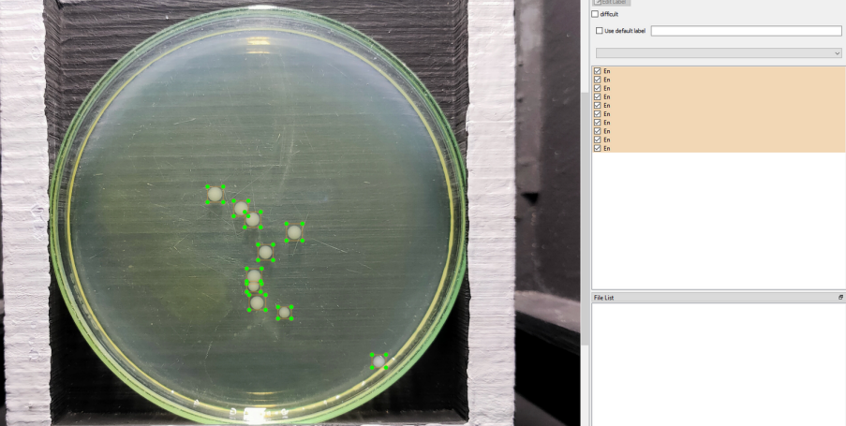

**Medthod**

**Dataset**

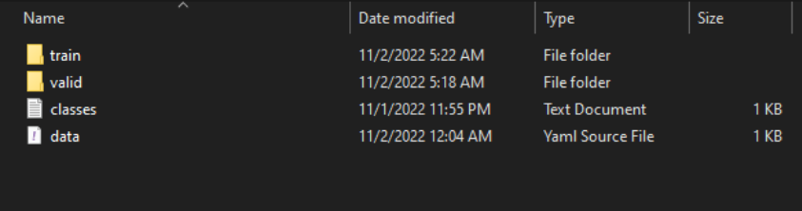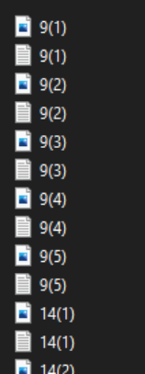

**train valid**

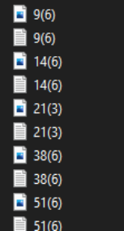

**Medthod**

**02.**

**Training**

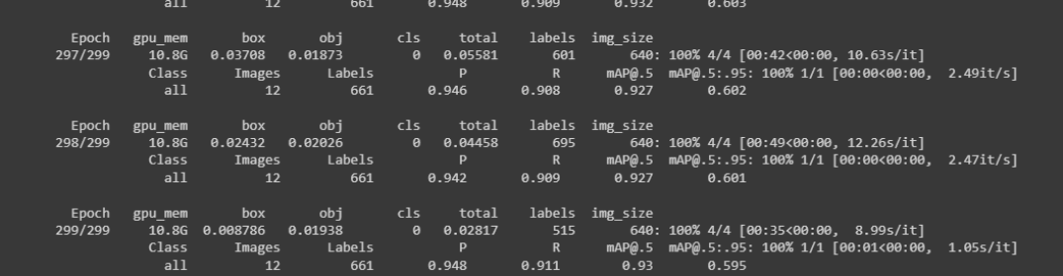

**Medthod**

**03.**

**Counting**

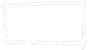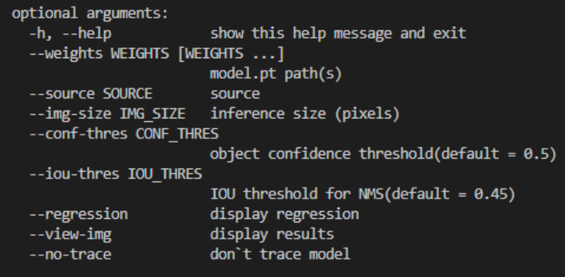

**Counting Result**

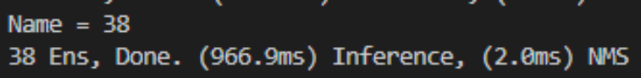

**Test with 300 colonies**

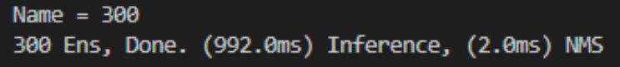

**Model Evaluations**

**Training result**

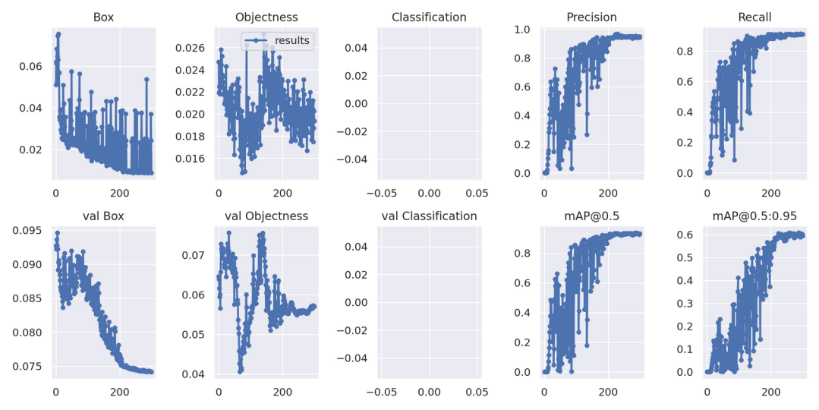

**Model Evaluations**

**F1**

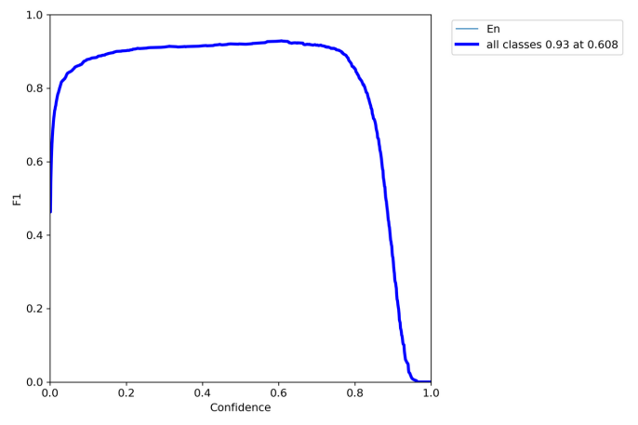

**Model Evaluations**

**Confusion Matrix**

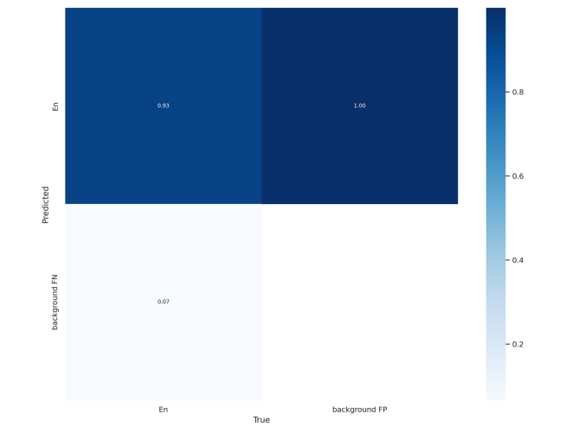

**Counter Evaluations**

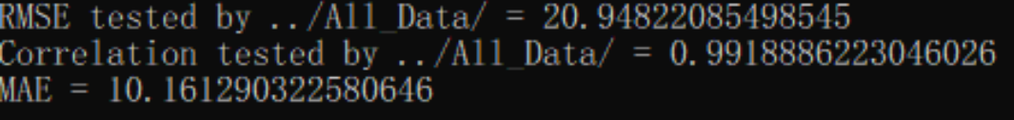test with 9-265 colonies

**End**